Homework 1

Jacob Taylor Cassady

CECS 535: Introduction to Databases

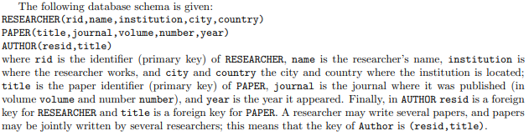

JSCHEMA <- RESEARCHER **JOIN[**rid=resid**]** AUTHOR **JOIN**[title=ptitle] **RENAME**[ptitle <- title] PAPER

# List the names of authors of any paper published in journal “Databases” in 2019 in volume 12.

RESULT <- **PROJECT[**name**]SELECT**[journal = ‘Databases’ and volume = 12 and year = 2019]JSCHEMA

# List the titles of any paper where at least one of the authors is from an institution in Boston, USA.

RESULT <- **PROJECT[**title**]SELECT**[city=”Boston” and country=”USA”]JSCHEMA

# List the names of authors who have published a paper in either “Nature” or “Science” (journals).

NATURE <- **PROJECT[**name**]SELECT**[journal=”Nature”]JSCHEMA

SCIENCE <- **PROJECT[**name**]SELECT**[journal=”Science”]JSCHEMA

RESULT <- NATURE **UNION** SCIENCE

# List the names of authors who have published a paper in both “Nature” and in “Science” (journals).

NATURE <- **PROJECT[**name**]SELECT**[journal=”Nature”]JSCHEMA

SCIENCE <- **PROJECT[**name**]SELECT**[journal=”Science”]JSCHEMA

RESULT <- NATURE **INTERSECT** SCIENCE

# List the names of authors who have never published a paper in “Nature” (journal).

NATURE <- **PROJECT[**name**]SELECT**[journal=”Nature”]JSCHEMA

RESULT <- **PROJECT**[name]JSCHEMA **-** NATURE

# List the names of authors who have published two or more papers in “Nature” (journal).

TWO_OR_MORE <- AUTHOR **JOIN**[resid=resid’] **RENAME**[resid’<-resid, title’<-title] AUTHOR

RESULT <- **PROJECT**[name]**SELECT**[journal=’Nature’](RESEARCHER **JOIN**[resid=resid’] **RENAME**[resid’<-resid] TWO_OR_MORE)

# List the names of authors who have published a paper in “Nature” but never in “Science” (journals).

NATURE <- **PROJECT[**rid**]SELECT**[journal=”Nature”]JSCHEMA

SCIENCE <- **PROJECT[**rid**]SELECT**[journal=”Science”]JSCHEMA

RESULT = **PROJECT**[name] RESERCHER **JOIN**[rid=rid’] **RENAME[**rid’<-rid**]**(NATURE – SCIENCE)

# List the names of authors who have published a paper in “Nature” (journal) alone (i.e. without co-authors).

# List the title of papers where all authors are from MIT (institution). Note: this includes sole authors too.

# List the pairs of authors who have co-authored a paper. Note: if a paper has 3 authors (say, Larry, Curly and Moe), then (Larry,Curly), (Curly,Moe) and (Larry,Moe) are co-authors. It’s ok to list both (Larry,Curly) and (Curly,Larry) in the answer.